motan on circular economy …
Plastics are too valuable to be thrown away

Today’s world – and our current prosperity – would not be possible without plastics for very many reasons. These polymer materials are used in the most diverse applications: for household appliances, automotive and aircraft manufacturing, in electronics, in the medical field and the construction sector. They are nearly indispensable for packaging materials, which contribute greatly to resource efficiency by functioning as insulation or light building material and thereby reducing heating oil and fuel consumption, or by extending the shelf life of food stuffs as packaging material.

However, it is also very clear that plastic waste has become a global problem that affects us all and needs to be solved by society as a whole. In addition, there is also the problem of an ever increasing demand for resources that are already scarce: many resources are limited and as the global population continues to grow, the demand for these resources is also steadily increasing. This is why circular economy is an important topic for the plastics industry.

Circular economy is a model for production and consumption, where existing materials and products are shared, leased, reused, repaired, reprocessed and recycled for as long as possible. This expands the life cycle of products. In practice, this means that waste is reduced to a minimum.

After a product has reached the end of its life, as much as possible of the resources and materials used to make it remain in the circular economy. They can then be productively reused in order to continue to generate added value.

Circular economy is the opposite of traditional, linear economy models – also known as throw-away economies. These models are based on large amounts of cheap and easily accessible materials and energy, something that is no longer the case in today’s world.

Being economical with the resources we have is one of the great challenges of our time. This is particularly true for the ever-dwindling reserves of fossil fuels. Therefore, a functioning circular economy can be a sensible and necessary addition to save and reduce consumption of the valuable resource “plastic”. It can also help to counteract the current negative image of plastics. This last point should not be underestimated in the often emotional and heated debate about plastics in general, and plastic waste in particular.

Plastics have ideal properties for recycling. However, a requirement for a functioning circular economy is that all actors along the entire supply chain work together and communicate with each other. For the plastics industry (plastics manufacturers, plastics processors, and plastics recyclers) this also applies to their customers and distributors, who influence the product design and the possibility of using a recycled material with their requirements and material specifications.

Another requirement for efficient circular economy is suitable material flow management with the goal of having mostly homogenous plastic waste. The more homogenous it is, the easier it is to reprocess it. One goal in this context is to generate the required amount to ensure supply with recycled materials. Advancements in the development of sorting systems for mixed material flows from general collection systems help to achieve this. Also, nowadays hardly any real production waste is produced, as this is directly fed back into running production or is passed on to specialized processors.

As a manufacturer of products and systems for material handling of bulk materials (granules, regrind, flakes and various powders), motan is a partner of three plastic subareas: manufacturing of virgin materials and recycled materials as well as plastic processing. In conjunction with the setup of circular systems, digitalization and the networking of production processes – generally referred to Industry 4.0 – also plays an important role in motan’s view. The data from dryers, dosing and mixing systems, and from crystallization has already been made available and can be used within the individual processes. In future, more data will follow, for example the composition of the material and its moisture content, recipes, material constants, and production data from the processing machine. It is important to bear in mind that the properties of recycled materials can change after repeated processing. This is where motan knowhow also comes into play, for example when precisely dosing additives for the making of regenerate.

Quality control will also require more data from the process than previously and will connect it with already acquired information. This will make additional sensors necessary in processing, both in the processing machines and in the tools. The digital network of all systems is currently one of the most important tasks motan is working on. The success of circular economy will depend on transparency, i.e. what exactly a product consists of and where this product is going. We already have first approaches to tag materials and make them identifiable. motan is developing solutions for automating the information flow of the material flow parallel to materials handling, in order to have a constant, digitalized information chain from goods in to the finished product.

If recycled materials are homogenous or well-sorted and prepared, there is almost no difference between them and virgin material. How important transparency in terms of origin and composition of material is, can be shown with the following example: If one material in a mix needs to be dried, this can lead to uncontrolled evaporation, which, worst case, can destroy the desiccant. If the material composition is known prior to drying, a suitable drying process can be planned. This requires the necessary documentation and quality control from the recycling cycle and the original processor.

For successful circular economy, everyone also needs to contribute in their role as a consumer. This means separating and avoiding any unnecessary waste and requires us to accept and choose products made from recycled materials. This is where we need to work on informing and educating ourselves and others.

Finally, it is also important to remain realistic as to the possibilities and limitations of circular economy. If mixed or contaminated waste can’t be recycled easily or well, it should be chemically recycled. There are already some early, promising projects working on this. Energetic recovery, preferably with efficient energy recovery, should be the very final stage of circular economy.

(7.502 characters)

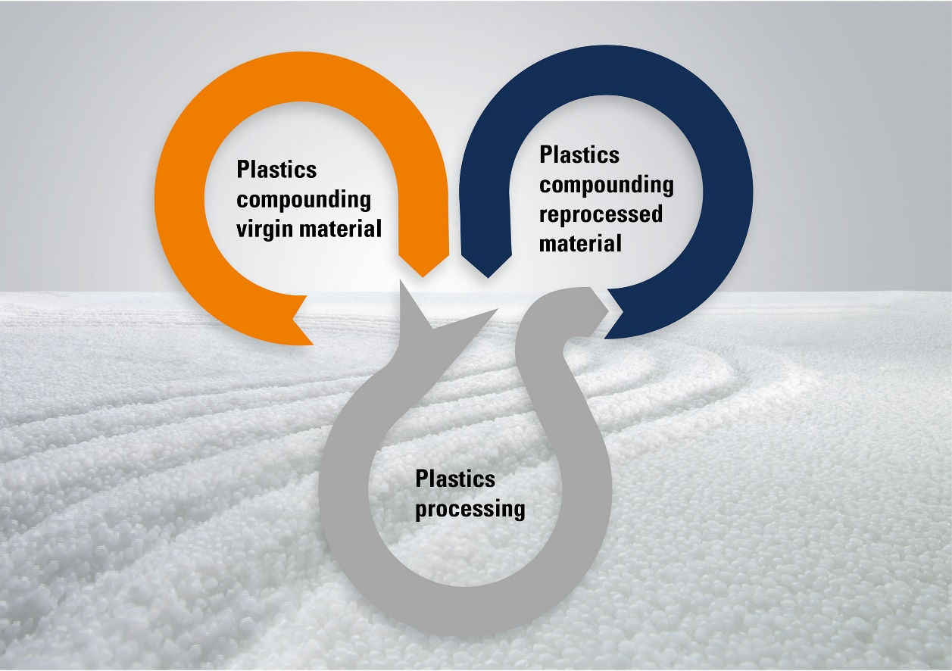
Graphic 1: motan’s materials management and the circular economy – data and material flow in the plastics industry (motan group)

The motan-group
The motan group based in Constance was founded in 1947. As leading provider for sustainable raw material handling, they operate in the areas injection moulding, blow moulding, extrusion and compounding. Innovative, modular system solutions for storage, drying and crystallisation, conveying, dosing, and mixing of raw materials for the plastics manufacturing and processing industries are part of the application orientated product range. Production takes place at different production sites in Germany, India, and China. motan-colortronic distribute their products and system solutions via their regional centres. With over 540 employees currently, a yearly turnover of roughly 132 million euros is achieved. Because of their network and long-standing experience, motan can offer their customers what they really need: Individually tailored solutions with real added value.

Contact:
motan holding gmbh
Carl Litherland
Stromeyersdorfstr. 12
78467 Konstanz / Germany

Tel. +49 7531 8178 15
carl.litherland@motan.com
www.motan.com

